**HCL LIBRARY MANAGEMENT SYSTEM**

Contents

**INTRODUCTION:**

- Project Purpose…………………………………………………………………………………………

- Project Scope……………………………………………………………………………………………

- Glossary & References……………………………………………………………………………

**OVERALL DESCRIPTION:**

- User Needs………………………………………………………………………………………………

- Assumptions and Dependencies…………………………………………………………………

**REQUIREMENT SPECIFICATION:**

**-** Functional Requirements……………………………………………………………………………

- Non-Functional Requirements…………………………………………………………………….

- External Interface Requirements………………………………………………………………...

- Performance Requirements…………………………………………………………………………

- Design Constraints………………………………………………………………………………….…

- Security Requirements……………………………………………………………………………….

**_________________**

**Introduction:**

**Project Purpose:**

The purpose of this project is to develop an Library Management System (LMS) for HCL. LMS will enable HCL to track and manage employee & book related data efficiently.

**Project Scope:**

The scope of this project is to develop an LMS which will enable HCL to manage employee & book related data such as add employee and book, issue book and return book, view book and employee.

**Glossary & References:**

LMS: Library Management System

HCL: Hindustan Computers Limited

**_________________**

**Overall Description:**

**User Needs:**

The LMS should enable HCL to efficiently and effectively manage employee & book related data. The system should be user friendly and easy to use.

**Assumptions and Dependencies:**

It is assumed that the LMS will be developed using Java as the programming language and MySQL as the database. The system should work on Windows and Mac systems.

**_________________**

**Requirement Specification:**

**Functional Requirements:**

**The LMS should have the following functional requirements:**

Developing an application for the “HCL Library management system”. With the given below functionality and all data must store in the database by making a connectivity form the java base console-application with the MySQL database.

**•** The system should enable HCL to store employee & book, including personal details and contact information.

* The system should have welcome page, login module, home module containing all the necessary stuffs for the management of library.

**Description:**

Here is an  **Library management system**. “Library management system – Home” module is used to manage the library details like adding employee and books, updating their data.

**RO1. Field Validation:**

o   **Login Module**

***Username*** *–* Text Field

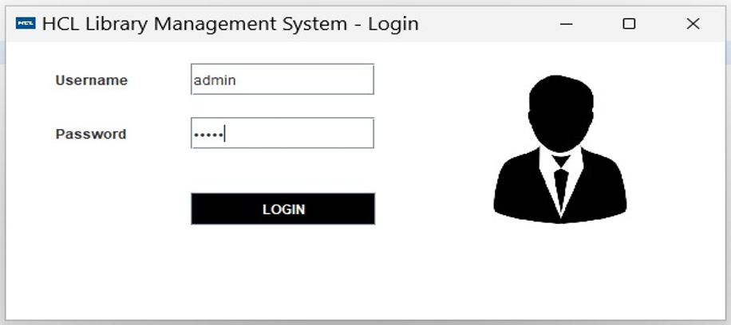

It will accept only alphabets.

* The values that is available in the current database is “admin”

***Password*** – Text Field

  It will accept only numeric values.

* The values that is available in the current database is “12345”

o   **Add New Book Module**

1. ***Book ID –*** Text Box is numeric; this field can accept 10 characters.
2. ***Book Name –*** Text Box is alphabetical; this field can accept 30 characters.
3. ***Available In -*** drop-down/list-box menu

Current values in database is (“English, Hindi, French, German, Japanese, Spanish”).

1. ***Author -*** Text Box is alphabetical; this field can accept 20 characters.
2. ***Publish Year -*** Calendar Box.

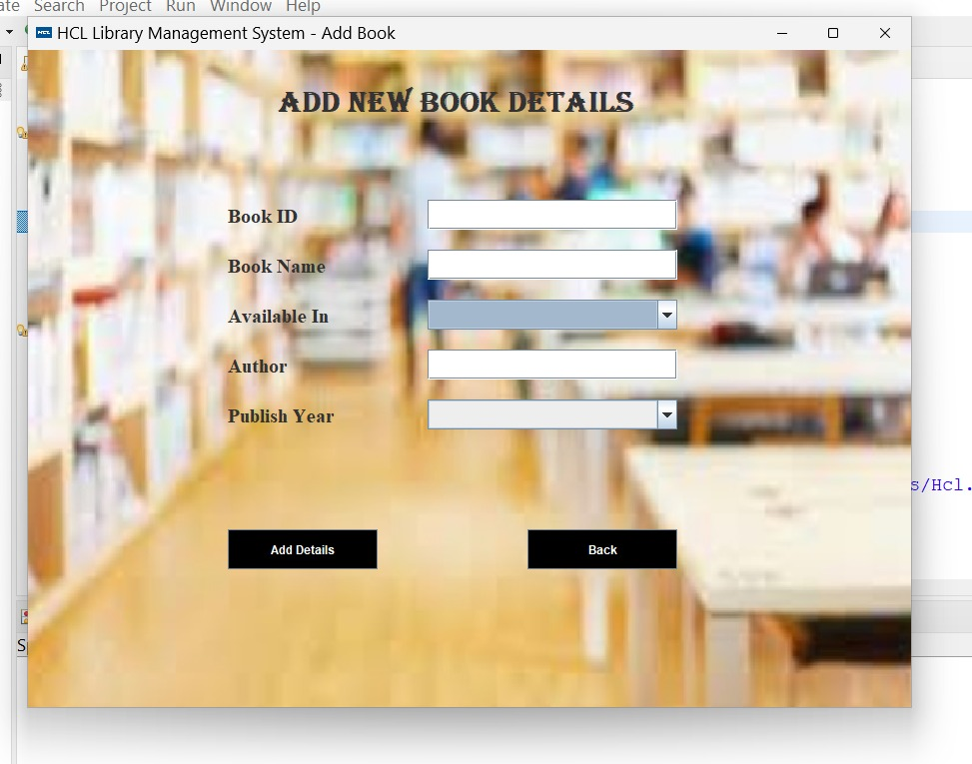

o   **Issue Book Module**

1. ***Book ID –*** Text Box is numeric; this field can accept 10 characters.
2. ***Book Name –*** Text Box is alphabetical; this field can accept 30 characters.
3. ***Author -*** Text Box is alphabetical; this field can accept 20 characters.
4. ***Issue date -*** Calendar Box.
5. ***Signature –*** Text Box.

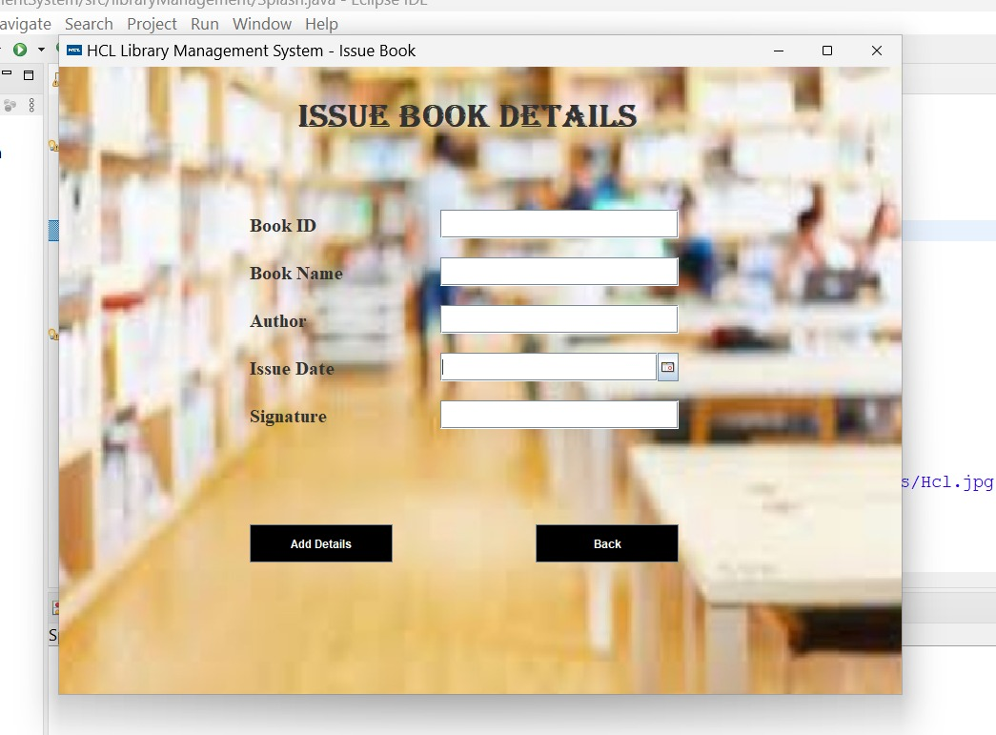

**Non-Functional Requirements:**

**The LMS should have the following non-functional requirements:**

• The system should be user friendly and intuitive.

• The system should provide an easy way to search and filter library data.

• The system should be secure and protect library data from unauthorized access.

• The system should be reliable and robust.

**External Interface Requirements:**

**The LMS should have the following external interface requirements:**

• The system should enable integration with other HCL systems.

• The system should enable integration with third party systems.

**Performance Requirements:**

**The LMS should have the following performance requirements:**

• The system should respond quickly to user requests.

• The system should be able to handle large amounts of data.

**Design Constraints:**

**The LMS should have the following design constraints:**

• The system should be developed using Java and MySQL.

• The system should be compatible with Windows and Mac systems.

**Security Requirements:**

**The LMS should have the following security requirements:**

• The system should protect employee data from unauthorized access.

• The system should have an authentication mechanism to verify users.

• The system should have an encryption mechanism to protect data transmission.